Vacuum Cleaner Problem
Aim
To implement the Vacuum Cleaner Problem in Python, where the vacuum cleaner cleans all dirty rooms by moving between them.
Algorithm
- Initialize the environment with two rooms (A and B).
- Check the current room.
- If the room is dirty, clean it.
- Move to the other room.
- Repeat the process until both rooms are clean.
- Display the final state of the rooms.
Python Code
# Vacuum Cleaner Problem

rooms = {
"A": "Dirty",
"B": "Dirty"
}

current_room = "A"

while True:
print(f"Vacuum is in Room {current_room}")

if rooms[current_room] == "Dirty":
print(f"Cleaning Room {current_room}")
rooms[current_room] = "Clean"
else:
print(f"Room {current_room} is already Clean")

# Check if all rooms are clean
if all(state == "Clean" for state in rooms.values()):
break

# Move to the other room
current_room = "B" if current_room == "A" else "A"

print("\nFinal State:")
for room, state in rooms.items():
print(f"Room {room}: {state}")
Output
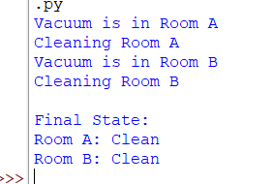
Result
The Vacuum Cleaner Problem was successfully implemented using Python. The vacuum cleaner cleaned all the dirty rooms and reached the goal state where every room was clean.

